## LPG GAS LEAKAGE DETECTION USING MQ 2 SENSOR FOR HOME SAFETY

Amutha M 1, a), Sudha V 2, b),Dhanush Adithyan S3,c) and Mahizhavan V4,d)

Author Affiliations

1Assistant Professor(Sr.G)

2 Assistant Professor

*Author Emails*

*a)Amutha M :*[*amutha@sonatech.ac.in*](mailto:amutha@sonatech.ac.in)

*b)Sudha V:* [*sudha.ece@sonatech.ac.in*](mailto:sudha.ece@sonatech.ac.in)

*c)Dhanush Adithyan S:*[*dhanushadityan.20ece@sonatech.ac.in*](mailto:dhanushadityan.20ece@sonatech.ac.in)

*d)Mahizhavan V:*[*mahizhavan.20ece@sonatech.ac.in*](mailto:mahizhavan.20ece@sonatech.ac.in)

***Abstract*** — As the widespread adoption of Liquefied Petroleum Gas (LPG) for household fuel necessitates robust safety measures, the MQ-2 gas sensor-based gas leakage detection system emerges as a solution for residential safety. This system ensures the timely identification of gas leakages by providing accurate and real-time gas readings. The MQ-2 sensor, renowned for its heightened sensitivity to various flammable gases, particularly LPG, operates by detecting gas concentrations through resistance changes in its sensitive element.By leveraging this sensing principle, the system continually monitors the air quality in its surroundings, swiftly signaling the presence of LPG gas. The primary objective of this innovative system is to establish precautionary measures in response to LPG gas leaks, enabling immediate actions to avert potential hazards. Engineered with user-friendliness and cost-effectiveness in mind, the system incorporates an automated window opening mechanism triggered during gas leakages, enhancing safety in residential settings. With ongoing advancements and refinements, this system holds the promise of significantly contributing to the creation of safer domestic environments in the future.

***Keywords— Liquefied Petroleum Gas (LPG), Microcontroller-Based System, Real-time Monitoring system***

1. **INTRODUCTION**

The threat posed by gas leakage to human safety is substantial, encompassing the potential for fires, explosions, and the release of toxic gases. Commonly utilized gases such as natural gas (methane), liquefied petroleum gas (LPG), carbon monoxide (CO), and others, crucial for residential and industrial purposes, can lead to perilous situations due to accidental leaks or malfunctioning gas equipment. To address these risks effectively, gas leakage detection systems have been devised to furnish early warnings and prioritize human safety.These systems are intricately designed to monitor air quality in an environment and identify the presence of hazardous gases. Employing various sensors calibrated to detect specific gases, they ensure accuracy in measuring gas concentrations. Triggering appropriate actions when predetermined thresholds are exceeded, these systems utilize sensors like MQ series gas sensors, electrochemical sensors, or infrared sensors for residential applications targeting common household gases.

Typically linked to a central control unit, the detection system processes sensor readings and activates alarms or alerts when gas concentrations surpass safe levels. Audible, visual, or combined alarms ensure immediate notification of potential danger to residents.

Some systems integrate with home automation or security systems, providing comprehensive safety features.Beyond early warnings, gas leakage detection systems enable prompt preventive measures. Upon detecting a gas leak, the system can automatically cut off the gas supply, activate ventilation systems, or notify emergency services or designated contacts. These proactive measures significantly diminish the risk of accidents, limit property damage, and save lives.Gas leakage detection systems, critical for human safety, play a pivotal role in detecting hazardous gases and issuing timely warnings. By incorporating advanced sensors and intelligent control units, these systems empower individuals and organizations to take immediate action, averting potential disasters associated with gas leaks. As technology advances, these systems are expected to evolve into even more sophisticated, reliable, and integrated solutions, offering enhanced safety features across various applications.

The Bhopal Gas Tragedy in 1984 stands as a stark reminder of the catastrophic consequences of uncontrolled gas leaks, emphasizing the urgent need for efficient gas leakage detection systems. Incidents like pipeline explosions and carbon monoxide poisoning further underscore the importance of continuous monitoring and rapid detection to prevent explosions, mitigate risks, and protect occupants.

Real-time incidents, such as the 2010 San Bruno pipeline explosion and the 2018 residential gas explosion in the United States, validate the significance of early detection systems. These incidents underscore the potential consequences of gas leaks, including loss of life, property damage, and long-term health issues. The introduction highlights the effectiveness of gas leakage detection systems in providing early warnings and enabling swift response measures to mitigate risks and save lives, aligning with the crucial role emphasized in real-world incidents.

1. **LITERATURE REVIEW**

The paper by S. Chawla and H. Chawla[14], titled "A Comparative Study on Monitoring of LPG Gas Cylinders to Prevent Hazards," likely delves into assessing various methods for monitoring LPG gas cylinders with the goal of preventing potential dangers. The study compare different technologies or approaches used in gas cylinder monitoring systems, analyzing factors such as accuracy, response time, and ease of implementation. The paper by T. Kar, S. Pahadsingh, N. C. Giri, M. Kharchenko, S. Leliuk, and M. Khrypunov, [15]titled "Smart LPG Gas Detection and Automatic Booking System for Home Safety Using IoT Platform," likely introduces a comprehensive system integrating IoT (Internet of Things) technology for LPG gas safety. The proposed system involve smart gas detection mechanisms, utilizing sensors similar to MQ-2 sensor, coupled with an automated booking system for LPG refills. The IoT platform facilitates real-time monitoring, alerts for gas leaks, and a seamless booking process for timely refills, enhancing overall home safety. This paper provide insights into the design, implementation, and effectiveness of such an integrated IoT solution for LPG gas management in residential settings.[12] The paper authored by D. Gautam, S. Bhatia, N. Goel, B. Mallikaijuna, G. H S, and B. Bhushan Naib, titled "Development of IoT Enabled Framework for LPG Gas Leakage Detection and Weight Monitoring System," describes the creation of an Internet of Things (IoT) framework dedicated to LPG gas safety. The system involve the integration of gas leakage detection MQ-2 sensor, and a weight monitoring system for LPG cylinders. This IoT-enabled framework offer real-time gas leakage alerts and track the weight of LPG cylinders, ensuring timely replacements and enhancing overall safety.[10] The paper by P. Soni, L. Aamir, R. R. S. Rathore, G. Yunus, M. Kuddus, and D. Rathore, titled "Sensitivity and Selectivity Between Test Gases in Set (1) LPG, Ethanol, and Acetone and Set (2) NH3, Methanol, and NO2 of BaTiO3/Ag/WO3 Nanocomposite," focuses on the characterization of BaTiO3/Ag/WO3 nanocomposite sensor materials. The study investigate the sensitivity and selectivity of this nanocomposite to various test gases, specifically in sets (1) and (2), including LPG, ethanol, acetone, NH3, methanol, and NO2. The research could provide insights into the potential application of BaTiO3/Ag/WO3 nanocomposites for gas sensing, especially in differentiating between specific gases for practical use in environmental or industrial monitoring.[1] The paper authored by M. A. F. Malbog, H. D. Grimaldo, L. L. Lacatan, R. M. Dellosa, and Y. D. Austria, titled "LPG Leakage and Flame Detection with SMS Notification and Alarm System: Rule-Based Method," presents a system for detecting LPG gas leakage and flames using a rule-based method. The system incorporate sensors for gas leakage and flame detection, integrating technologies like MQ-2 sensors.[9]The paper authored by A. Nag, A. I. Zia, X. Li, S. C. Mukhopadhyay, and J. Kosel, titled "Novel Sensing Approach for LPG Leakage Detection: Part I—Operating Mechanism and Preliminary Results," explores a new sensing approach for detecting LPG gas leakage. The focus in Part I of the paper include detailing the operating mechanism of the novel sensing method and presenting preliminary results obtained from experiments and tests. The inclusion of an SMS notification and alarm system suggests a practical approach for immediate alerts to users. [8]The paper by S. Chawla and H. Chawla, titled "A Comparative Study on Monitoring of LPG Gas Cylinders to Prevent Hazards," involves an analysis of various methods or technologies employed for monitoring LPG gas cylinders with the aim of preventing potential hazards. The study compare different monitoring systems in terms of accuracy, reliability, and effectiveness in preventing LPG-related risks.

1. **EXISTING SYSTEM**

The functioning of the alarm and SMS systems relies on the premise of gas sensor outputs surpassing predefined threshold levels. Once the gas sensor identifies an elevated concentration of LPG gas, it transmits a signal to the central control unit or microcontroller, triggering the activation of an alarm system. This alarm system may manifest as an audible sound, a visual indicator, or a combination of both, strategically positioned within the premises. [2]The paper by B. Siregar, H. A. Daulay, and D. Arisandi, titled "Internet-Based Control System of Things on Cylinder Regulator for Safety from LPG Gas Leak Hazards," explores an Internet of Things (IoT) based control system designed to enhance safety in LPG usage. The focus may be on implementing IoT technology on cylinder regulators to detect and mitigate LPG gas leaks. Its primary objective is to promptly alert individuals in the vicinity about the potential gas leak, urging them to undertake necessary safety measures or evacuate the area.

In addition to the audible and visual alerts, the system incorporates an SMS notification feature to extend remote alerts to homeowners or designated contacts. The paper[4]by M. H. B. M. Yaya, R. K. Patchmuthu, and A. T. Wan, titled "LPG Gas Usage and Leakage Detection Using IoT in Brunei,"explores the implementation of an Internet of Things (IoT) system to monitor LPG gas usage and detect potential leaks in the context of Brunei. This paper include sensors, possibly similar to the MQ-2 sensor, to monitor gas consumption patterns and promptly identify any gas leakage. Upon detecting a gas leak, the system initiates the sending of an SMS message to preprogrammed mobile numbers [1] The inclusion of an SMS notification and alarm system suggests a practical approach for immediate alerts to users., notifying recipients of the situation. This feature ensures swift information dissemination, particularly useful when occupants are not physically present on-site. The SMS message typically includes pertinent details such as the type of gas detected, the location, and instructions for responding to the gas leak.[3] The paper by S. Reddy and R. P. K N, titled "LPG Gas Detection and Monitoring Using IoT," discusses a system that employs the Internet of Things (IoT) for monitoring and detecting LPG gas. The focus may be on utilizing sensors, potentially including MQ-2 or similar gas sensors, to detect LPG gas leaks. The IoT infrastructure facilitates real-time monitoring, data collection, and potentially remote control or notifications. This approach aims to enhance safety by providing timely information and automated responses in the case of LPG gas detectionThe integration of alarm and SMS systems centered around LPG gas detection significantly elevates the safety measures for homes. This combined approach enhances the effectiveness of timely notifications, providing residents with critical information to respond appropriately to potential gas leaks.

1. **PROPOSED SYSTEM**

The envisioned system, known as the "LPG Gas Leakage Detector," has been meticulously designed and developed to execute various tasks within the challenging environment of an industrial setting. This intelligent apparatus comprises multiple units, including an LPG gas sensor, microcontroller, relay, fan, DC motor, and driver circuit, all working in unison under the control of the microcontroller. Representing a notable advancement in technology, this prototype system holds the potential for effective and efficient application across diverse dimensions, catering to the requirements of industrial, research, and commercial contexts. [5]The focus include a LPG gas real-time monitoring and safety features providing advanced features and real-time insights into the status of gas cylinders.Different types of sensors are commonly employed for LPG gas detection owing to their sensitivity and ability to discern specific gases. These include MQ Series Gas Sensors, Catalytic Bead Sensors, Infrared (IR) Sensors, Electrochemical Sensors, and Ultrasonic Gas Leak Detectors. MQ series sensors, characterized by their cost-effectiveness, emerge as a favored choice, particularly in residential settings. They exhibit a rapid response time and high sensitivity to flammable gases, capable of detecting low concentrations, ranging from a few hundred parts per million (ppm) to several thousand ppm.

The MQ-2 sensors, designed primarily for detecting flammable gases, can also respond to other gases such as smoke and alcohol vapors.[6] The MQ-2 sensor monitor gas levels and promptly identify any gas leakage. This system may offer real-time data on gas levels and trigger alerts or alarms in case of detected leaks, enhancing safety measures associated with LPG usage. However, their selectivity may vary, and cross-sensitivity to certain gases is possible.[7] The paper authored by G. N. Sai, K. P. Sai, K. Ajay, and P. Nuthakki, titled "Smart LPG Gas Leakage Detection and Monitoring System,"describes a system that incorporates smart technology for detecting and monitoring LPG gas leaks. Operating at a low voltage, typically around 5V, these sensors demonstrate compatibility with a broad spectrum of electronic systems and microcontrollers. A warm-up period is required before they stabilize and provide accurate readings, usually lasting a few minutes during which the sensor needs to be powered to reach its operating temperature.

Furthermore, MQ series sensors generate analog output voltage that varies based on the detected gas concentration. This output can be interfaced with analog-to-digital converters or microcontrollers for the measurement and interpretation of gas concentration levels. The system's integration of these sensors enhances its capability for real-time gas detection and prompt alerts in the event of a gas leak

1. **WORKING OF THE SYSTEM**

The Arduino UNO board, MQ2 sensor, relay with a fan, DC motor, and light circuit are interconnected in a unified system. The microcontroller governs this integration, with the MQ2 sensor directly linked to it, while the remaining components are also connected to the microcontroller. Upon detecting gas or smoke, the MQ2 sensor transmits a signal to the microcontroller, initiating a sequence of actions. Subsequently, the microcontroller relays the signal to the connected relay, which controls the operation of the fan, light circuit, and DC motor.

In response to the signal received from the sensor, the microcontroller orchestrates the activation of the exhaust fan, the opening of windows facilitated by the DC motor, and the deactivation of the light circuit. This operational sequence ensures that in the presence of detected gas or smoke, the exhaust fan is set into motion, windows are opened for ventilation through the DC motor, and the light circuit is turned off. Such a systematic approach enhances the overall functionality and safety of the system.

1. **BLOCK DIAGRAM OF PROPOSED SYSTEM**

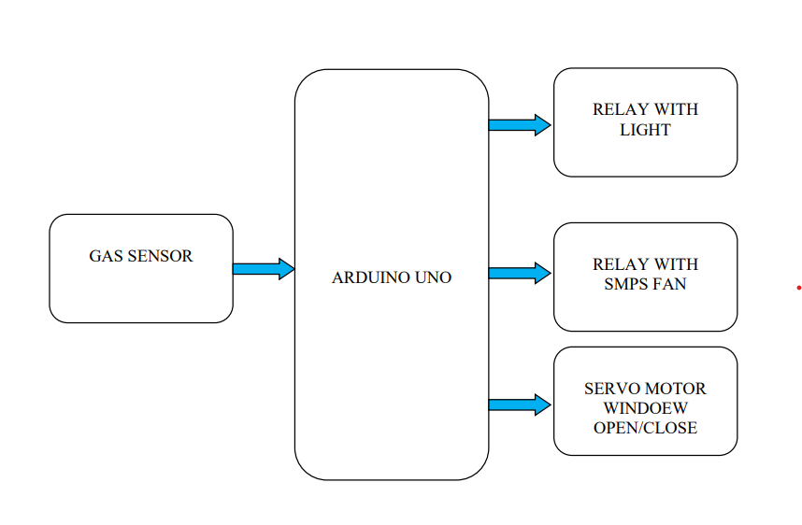

Fig-1 Block Diagram of LPG gas leakage Detection System

1. **FLOW CHART**

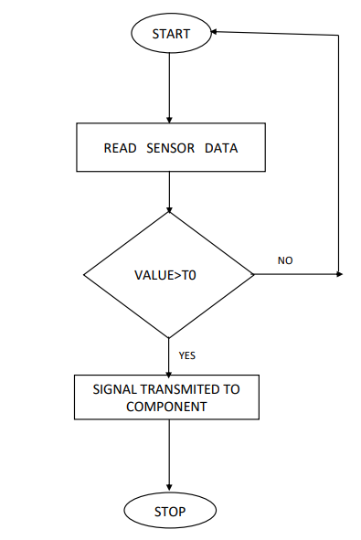

Fig-2 Flow Chart of the Working Process

1. **HARDWARE SETUP**

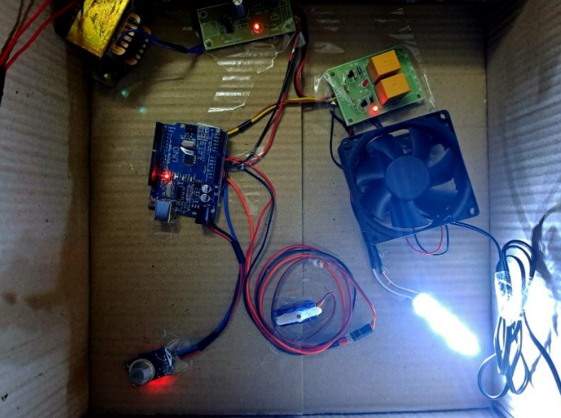

Fig-3 Experimental setup

1. **RESULT**

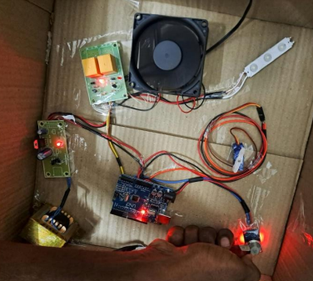

Fig-4 Output when Gas is detected

1. **CONCLUSION AND FUTURE WORK**

In conclusion, the implementation of an LPG gas detection system using the MQ-2 sensor has proven to be effective in ensuring safety and preventing potential hazards. The sensor demonstrated reliable performance in detecting LPG gas leaks, providing timely alerts and enhancing the overall security of the environment.

Refining the sensor calibration process can significantly improve the accuracy and sensitivity of gas detection, ensuring a more precise response to varying LPG concentrations. Broadening the system's capabilities to detect multiple gases will increase its versatility, making it suitable for environments where various gas types may coexist. Creating a user-friendly interface for configuration and monitoring is essential to cater to users with diverse technical backgrounds. This may include the development of a dedicated mobile app or a web-based interface to enhance accessibility and usability.

1. **REFERENCES**
2. M. A. F. Malbog, H. D. Grimaldo, L. L. Lacatan, R. M. Dellosa and Y. D. Austria, "LPG Leakage and Flame Detection with SMS Notification and Alarm System: Rule-Based Method," 2020 11th IEEE Control and System Graduate Research Colloquium (ICSGRC), Shah Alam, Malaysia, 2020, pp. 323-327, doi: 10.1109/ICSGRC49013.2020.9232494.
3. B. Siregar, H. A. Daulay and D. Arisandi, "Internet-Based Control System of Things on Cylinder Regulator for Safety from LPG Gas Leak Hazards," 2023 10th International Conference on Electrical Engineering, Computer Science and Informatics (EECSI), Palembang, Indonesia, 2023, pp. 116-122, doi: 10.1109/EECSI59885.2023.10295790.
4. Reddy and R. P. K N, "LPG Gas Detection and Monitoring Using IoT," 2022 International Interdisciplinary Humanitarian Conference for Sustainability (IIHC), Bengaluru, India, 2022, pp. 693-697, doi: 10.1109/IIHC55949.2022.10060195.
5. M. H. B. M. Yaya, R. K. Patchmuthu and A. T. Wan, "LPG Gas Usage and Leakage Detection Using IoT in Brunei," 2021 International Conference on Green Energy, Computing and Sustainable Technology (GECOST), Miri, Malaysia, 2021, pp. 1-5, doi: 10.1109/GECOST52368.2021.9538647.
6. S. Chawla and H. Chawla, "IoT-Based Digital LPG Gas Cylinder Trolley to Prevent Hazards with Voice-Controlled Features," 2023 6th International Conference on Information Systems and Computer Networks (ISCON), Mathura, India, 2023, pp. 1-6, doi: 10.1109/ISCON57294.2023.10112147.
7. R. R. Kumar, M. Namachivayam, M. Deviprakash, V. Pradeep, K. Selvakumar and G. Sharunithi, "LPG Gas Level Monitoring and Leakage Detection System," 2023 International Conference on Self Sustainable Artificial Intelligence Systems (ICSSAS), Erode, India, 2023, pp. 1463-1468, doi: 10.1109/ICSSAS57918.2023.10331805.
8. G. N. Sai, K. P. Sai, K. Ajay and P. Nuthakki, "Smart LPG Gas Leakage Detection and Monitoring System," 2023 5th International Conference on Smart Systems and Inventive Technology (ICSSIT), Tirunelveli, India, 2023, pp. 571-576, doi: 10.1109/ICSSIT55814.2023.10060970.
9. S. Chawla and H. Chawla, "A Comparative Study on Monitoring of LPG Gas Cylinders to Prevent Hazards," 2023 3rd International Conference on Advance Computing and Innovative Technologies in Engineering (ICACITE), Greater Noida, India, 2023, pp. 1479-1484, doi: 10.1109/ICACITE57410.2023.10182432.
10. A.Nag, A. I. Zia, X. Li, S. C. Mukhopadhyay and J. Kosel, "Novel Sensing Approach for LPG Leakage Detection: Part I—Operating Mechanism and Preliminary Results," in IEEE Sensors Journal, vol. 16, no. 4, pp. 996-1003, Feb.15, 2016, doi: 10.1109/JSEN.2015.2496400.
11. P. Soni, L. Aamir, R. R. S. Rathore, G. Yunus, M. Kuddus and D. Rathore, "Sensitivity and Selectivity Between Test Gases in Set (1) LPG, Ethanol, and Acetone and Set (2) NH3, Methanol, and NO2 of BaTiO3/Ag/WO3 Nanocomposite," in IEEE Sensors Journal, vol. 23, no. 21, pp. 25708-25715, 1 Nov.1, 2023, doi: 10.1109/JSEN.2023.3315328.
12. A.Macker, A. K. Shukla, S. Dey and J. Agarwal, "ARDUINO Based LPG Gas Monitoring … Automatic Cylinder Booking with Alert System," 2018 2nd International Conference on Trends in Electronics and Informatics (ICOEI), Tirunelveli, India, 2018, pp. 1209-1212, doi: 10.1109/ICOEI.2018.8553840.
13. D. Gautam, S. Bhatia, N. Goel, B. Mallikaijuna, G. H S and B. Bhushan Naib, "Development of IoT Enabled Framework for LPG Gas Leakage Detection and Weight Monitoring System," 2023 International Conference on Device Intelligence, Computing and Communication Technologies, (DICCT), Dehradun, India, 2023, pp. 182-187, doi: 10.1109/DICCT56244.2023.10110294.
14. M. Santiputri and M. Tio, "IoT-based Gas Leak Detection Device," 2018 International Conference on Applied Engineering (ICAE), Batam, Indonesia, 2018, pp. 1-4, doi: 10.1109/INCAE.2018.8579396.
15. S. Chawla and H. Chawla, "A Comparative Study on Monitoring of LPG Gas Cylinders to Prevent Hazards," 2023 3rd International Conference on Advance Computing and Innovative Technologies in Engineering (ICACITE), Greater Noida, India, 2023, pp. 1479-1484, doi: 10.1109/ICACITE57410.2023.10182432.
16. T. Kar, S. Pahadsingh, N. C. Giri, M. Kharchenko, S. Leliuk and M. Khrypunov, "Smart LPG Gas Detection and Automatic Booking System for Home Safety Using IoT Platform," 2023 IEEE 4th KhPI Week on Advanced Technology (KhPIWeek), Kharkiv, Ukraine, 2023, pp. 1-5, doi: 10.1109/KhPIWeek61412.2023.10312969.
17. Amutha, M .,Krishna, A.P.J., Jeya, S., ...Kavibharathi, M., Lohitha, B “Surveillance of farms from birds using raspberry pi”.Journal of Advanced Research in Dynamical and Control Systems, 2020, 12(7 Special Issue), pp. 578–585.
18. Saranya, K., Vijayashaarathi, S., Amutha, M “Automatic detection of vehicle entry into a restricted area using IoT”.International Journal of Recent Technology and Engineering, 2019, 8(1 Special Issue 4), pp. 1055–1057.
19. Prasad.B, N. Kumaratharan, J. Lenin, , J. Umamageswaran, (2023) Industries Fire Accident Tracking System Based on Internet of Things Using Arduino UNO. In 7th International Conference Intelligent Computing and Control Systems held in Vaigai College of Engineering, Madurai on 17th – 19th May 2023.
20. K. Keshamoni and S. Hemanth, "Smart Gas level monitoring gas leakage detector over IOT", IEEE 7th international advance computing conference (IACC), pp. 330-332, 2017.
21. Amutha, M., Krishna, A.P.J., Ramkumar, S., Oviyaa, B. “Zigbee based condition monitoring in ac motors using atmega16” International Journal of Pharmaceutical Research, 2020, 12(4), pp. 1089–1092.
22. Sudha,V.,Mohammed Imamudeen, S.K.,Poorvasindhu.D.,Kavya, S."IoT based Smart Prepaid Digital Multi-function Electricity Meter", Proceedings of the 2nd International Conference on Applied Artificial Intelligence and Computing, ICAAIC 2023, 2023, pp. 1420–1423.
23. Kavitha, K.R.,Vijayalakshmi, S.,Babu, B.M.,Roshan, D.R.,Kalaivani, K."Forest Fire Detection and Prevention System"Lecture Notes in Networks and Systems., 2023, 492, pp. 629–635.